NATIONAL UNIVERSITY OF MODERN LANGUAGE ISLAMABAD
Lab task:-05


Submitted to:
Mr. Meesam Raza
Submitted by:
Zulqarnain Hassan (SP21379)
Subject: …………………… Operating System
Department: ……………… BSSE-4-Afternoon
Date: ………………………. 28-03-2024

Task #01

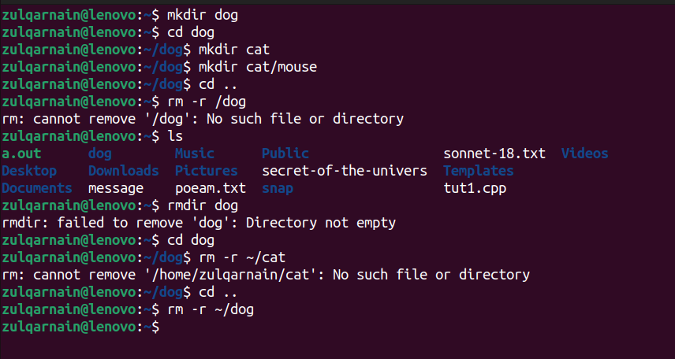

Task #02

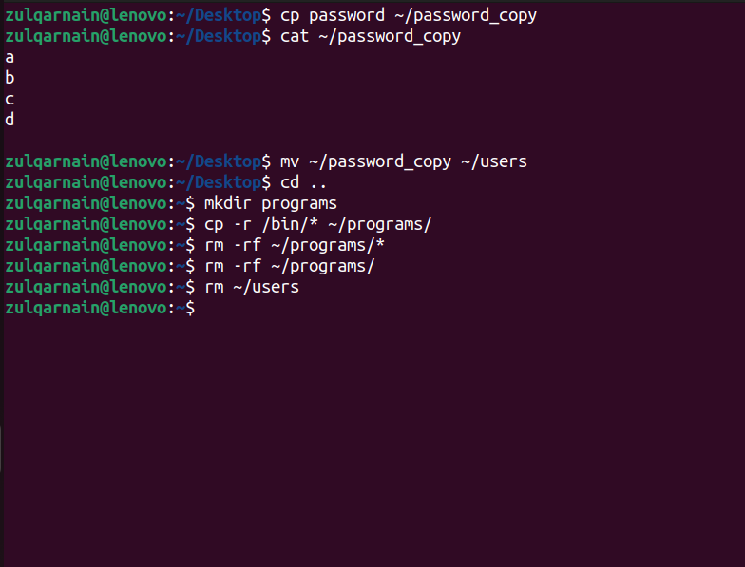

Task #03

